Week-01-Overview of C, Constants, Variables and Data Types

Week-01-01-Practice Session-Coding

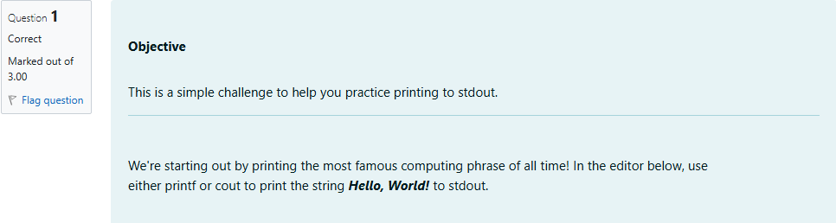

Source Code

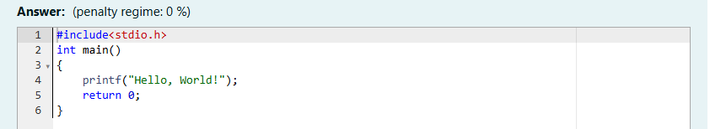

Result

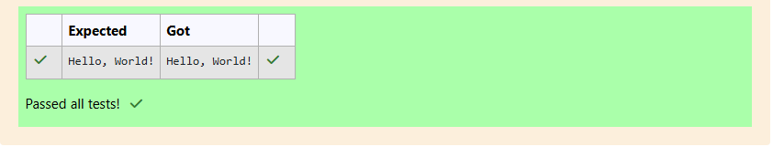

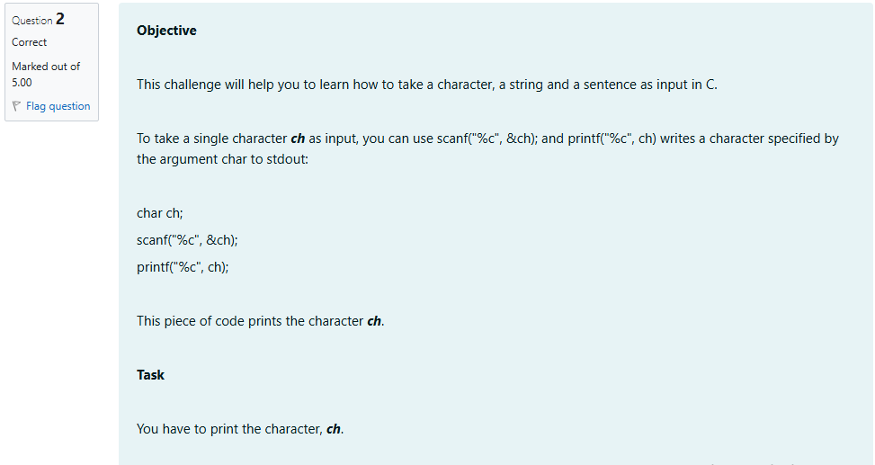

Source Code

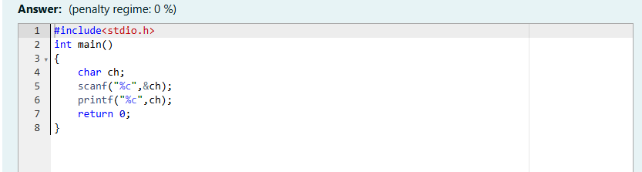

Result

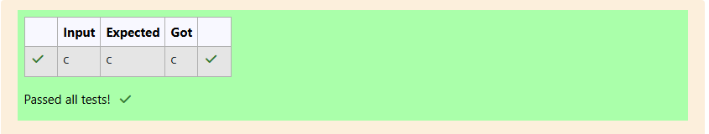

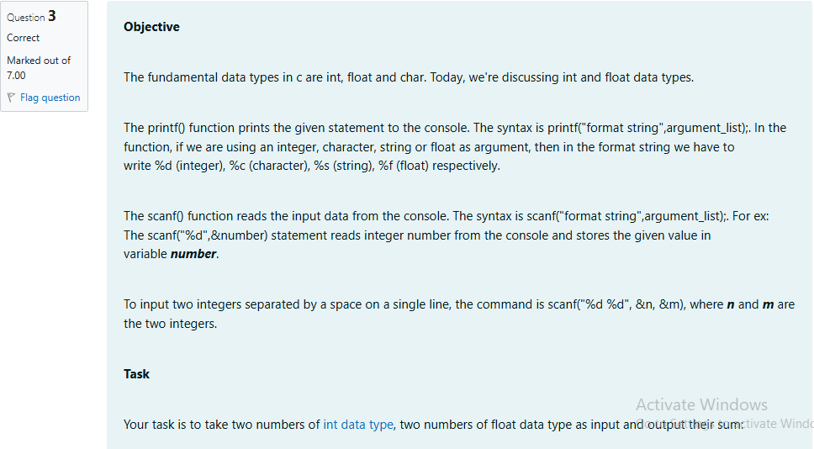

Source Code

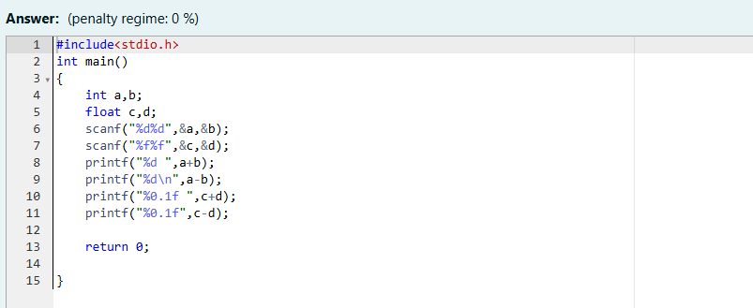

Result

